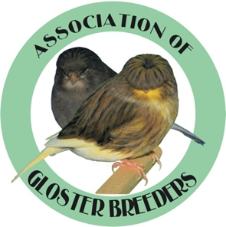
ASSOCIATION OF GLOSTER BREEDERS
Membership Application for 2021
Membership runs from Jan 1 – Dec 31

Dues:
Single Membership @ $20.00 a Year (U.S. funds)_______
Dual Membership @ $30.00 a Year (U.S. funds ________
Is this a Renewal ______ or New ______ Membership?

Names(s) Membership to be listed as:

Name(s):_______________________________________________________________

Address:_______________________________________________________________

City/State/Zip:__________________________________________________________

Email:__________________________________________________________________

Phone:_________________________________________________________________

PLEASE NOTE:
1.) When requesting bands for 2021: (remember to add $2.00 for
shipping, as bands will not be shipped if not included)
2.) Bands are sold in sets of 25 only & are $10.00 a set.
NUMBER OF BANDS REQUESTED:_______________
Total amount due on bands plus the $2.00 for shipping: $__________
===========================================================
_______: Yes I would like my name(s) placed in the Association of Gloster breeders National Catalog Ad for the year 2021 for $10.00 (*This nis a good way to show your support of the Gloster Canary and the Club.)
===========================================================
Total amount due: $___________ (including membership, bands, shipping and ad space if indicated.

Make checks/money orders payable to : AGB
Remit to: 715 AVOCADO COURT
DEL MAR CA 92014

You may also, pay via PayPal using associationofglosterbreeders@gmail.com or via Zelle using 858-245-3896

